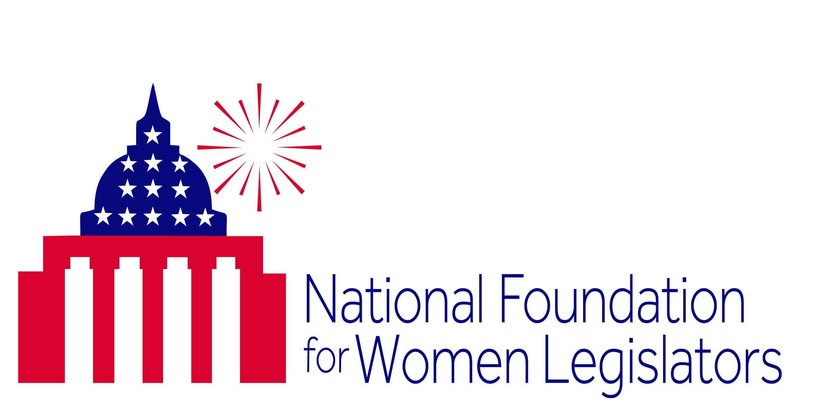

**You’re invited to join (host) for**

**“A Night at the Movies with Alice Paul”**

***Her fight for suffrage!***

***Her crusade for equal rights!***

***Remembe*r *Alice Paul at an NFWL “Make a Difference Movie Night”***

(Member) will be hosting a free showing of “Iron Jawed Angels”

(Day), (Date)   
at (Time)

(Location)

Come spend the evening honoring the great women of history!

This event is brought to you by the National Foundation for Women Legislators