Making Medicines More Affordable: Making coupons count
Emilie SignoraNovember 5, 2021
Making Medicines More Affordable: Making coupons count.
Share This
Common-sense reforms can help ensure everyone benefits from America’s engine of innovation and receives the care they need and deserve. In this series, we’re taking a closer look at PhRMA’s advocacy efforts to make medicines more affordable, part of our patient-centered agenda which aims to lower barriers between our industry’s medical innovations and patients who need them.
When patients face high out-of-pocket costs, they increasingly turn to manufacturer cost-sharing assistance to help them afford their medicines. But in some cases, health insurance companies and middlemen known as pharmacy benefit managers (PBMs), do not allow the assistance manufacturers provide to patients to count toward deductibles or out-of-pocket limits, meaning people could be paying thousands more at the pharmacy.
Many patients are facing high out-of-pocket costs due to increasing use of coinsurance and deductibles, specifically those with complex and chronic diseases. Patients with deductibles and coinsurance often pay for their medicines based on the undiscounted list price rather than the negotiated net price that their insurer pays, exposing patients to high costs. In 2019, compared to patients with fixed copays, patients with deductibles and coinsurance taking brand medicines to treat their cancer paid, on average, 25 times more out of pocket.
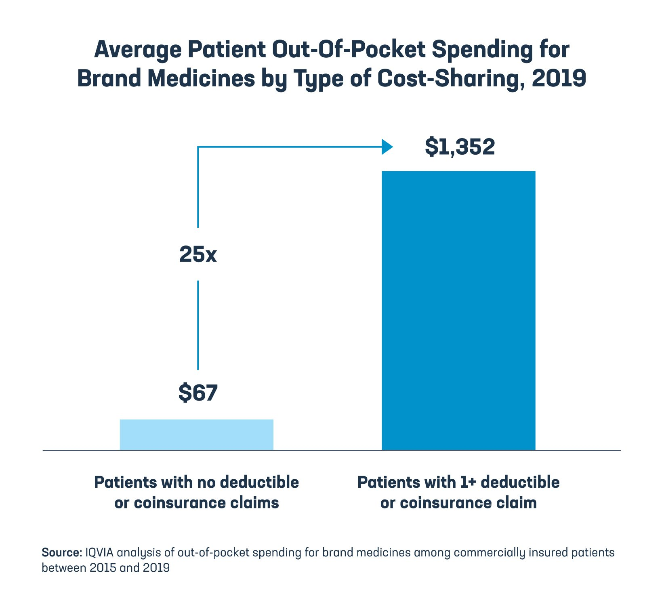
To help commercially insured patients afford their out-of-pocket costs, some biopharmaceutical companies offer cost-sharing assistance in the form of coupons. This has become a critical lifeline for many patients. Nearly 1 in 3 patients taking brand cancer medicines used manufacturer cost-sharing assistance to lower their out-of-pocket costs in 2019. Patients who used cost-sharing assistance for brand cancer medicines saved an average of $1,695 in 2019. Without this assistance, patients’ average out-of-pocket costs would have been more than four times higher.
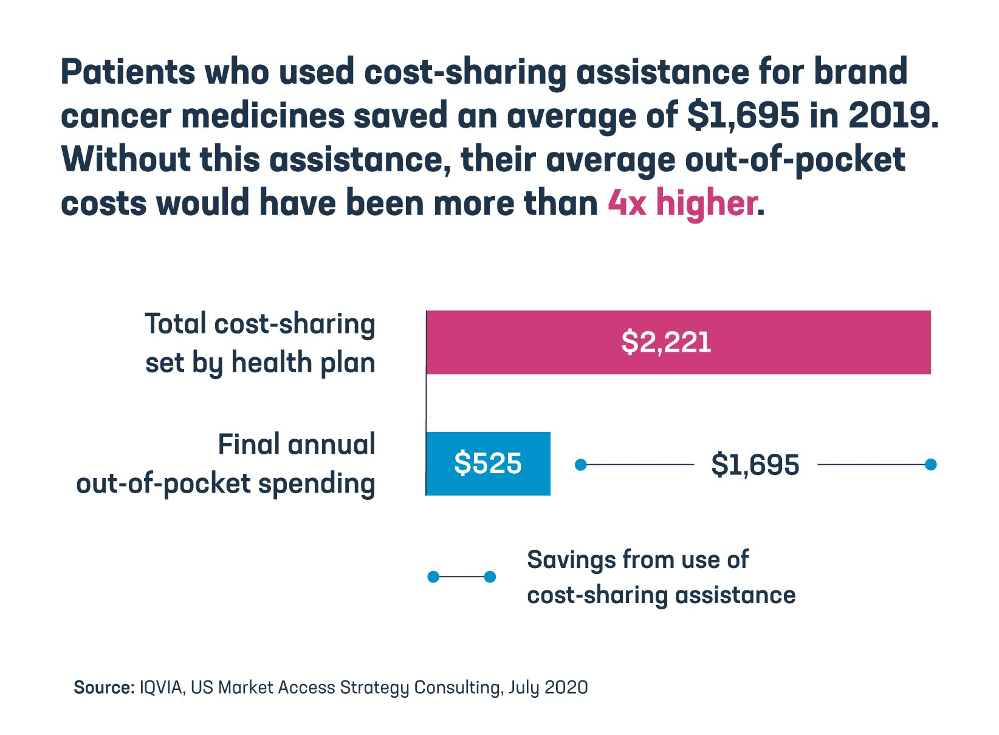
Increasingly, health plans do not allow the assistance manufacturers provide to patients to count toward deductibles or out-of-pocket limits, meaning people could be paying thousands more at the pharmacy. Accumulator adjustment programs, implemented by health plans and PBMs, exclude cost-sharing assistance from patients’ deductibles and out-of-pocket maximums.
When a patient’s cost-sharing assistance runs out, they may face surprise out-of-pocket costs, commonly known as a “copay surprise,” where they find out that their insurer won’t count the cost-sharing assistance toward their deductible or out-of-pocket maximums. This can leave patients exposed to out-of-pocket costs that they may not be able to afford, prompting many to abandon treatment, which in turn may lead to adverse health outcomes and drive up future health costs.
A new analysis by IQVIA looked at three cost-sharing assistance programs and found that from 2018 to 2020, 25% to 36% of patients discontinued treatment when they faced a copay surprise of $1,500 or more in the middle of the plan year.
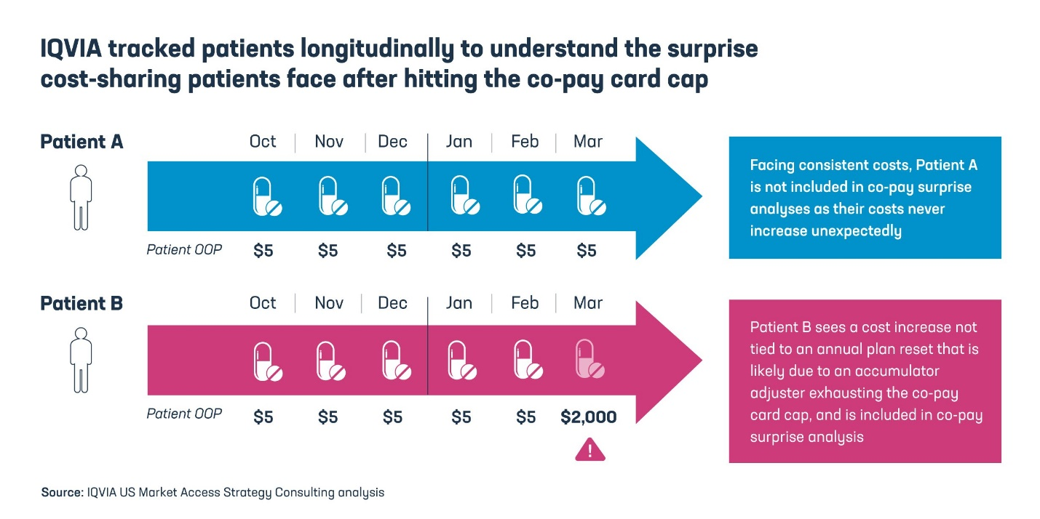
In recent years, middlemen have tripled the use of accumulator adjustment programs. We need to end this practice and ensure that people get the full benefit of the programs meant to help them afford their medicines. Unfortunately, HHS policies impacting the ability of manufacturer assistance to count towards patient out-of-pocket limits and making it harder for manufacturers to offer assistance can make it more difficult for patients to afford the medicines they need. Instead, we need policies that make coupons count by ensuring cost-sharing assistance applies to patient out-of-pocket limits.
Learn more at PhRMA.org/BetterWay.
Topics: Out-of-Pocket Costs, Proactive Agenda

